SLK-M200W Series
3G Modem

Specification

Data: 2015-6-6

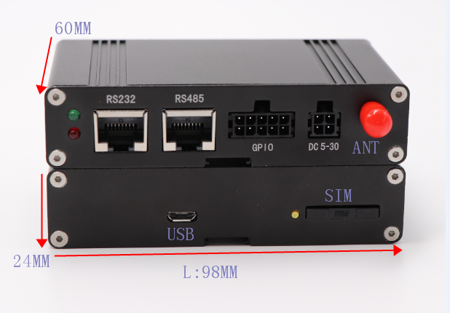

SLK-M200W is a WCDMA/HSDPA terminal GPS(optional) based on the advanced SIM5320 series module solution which supports HSDPA up to 3.6Mbps for downlink data transfer. With a wide range of industrial interfaces and extended working temperature range, the reliable terminal is an ideal solution for most applications such as remote maintenance & control, environmental monitoring, transportation and security etc. It allows quick and easy implementation, reduces customer cost significantly and lowers the entry barries to wide range M2M business.

SLK-M200W supports LUA Script Language, which provides the possibility for customers to develop and run programs inside the modem itself and meet various customers' needs. With standard serial RS-232 interface, customer can easily implememt the data flow control, hardware or software flow control according to their own requirements.

The firmware upgrading will be available by FOTA or via USB interface.

Details:
General features
Band
SLK-M200W_A | Dual-Band UMTS/HSDPA 850/1900MHz  Quad-Band GSM/GPRS/EDGE 850/900/1800/1900MHz
SLK-M200W_E | Dual-Band UMTS/HSDPA 850/1900MHz  Quad-Band GSM/GPRS/EDGE 850/900/1800/1900MHz
SLK-M200W_J | Dual-Band UMTS/HSDPA 850/2100MHz  Quad-Band GSM/GPRS/EDGE 850/900/1800/1900MHz
Standard | • GPRS multi-slot class 12  • EDGE multi-slot class 12  • WCDMA 3GPP release 5
Data transfer:
Specifications  Data transfer | • HSDPA- Max. 3.6Mbps(DL)  •WCDMA- Max. 384Kbps(DL), - Max. 384Kbps(UL)  • EDGE Class: - Max. 236.8Kbps(DL),- Max. 118Kbps(UL)  • GPRS- Max. 85.6Kbps(DL), - Max.42.8Kbps(UL)  • CSD- GSM data rate 14.4Kbps- WCDMA data rate 57.6Kbps
Interfaces:
Interfaces
SIM Card | Internal SIM 1.8V/3.0V
ANT | GSM/WCDMA Antenna
Serial Port | Port1:RS232-RJ45 connector  Pin1-VCC (input VCC from serial port)  Pin2-3-NC,Pin4-TXD(output),Pin5-RXD(input),Pin6-GND,Pin7-DTR(input)  Pin8-NC  Port2:RS485-RJ45 connector  Pin1-VCC (input VCC from serial port),Pin2-RS485-B,Pin3-NC,Pin4- RS485-A  Pin5-NC,Pin6-GND,Pin7-NC,Pin8-NC
GPIO | 10pin Connector  ADC  GPIOs
USB | USB2.0 interface
Power | Supply voltage range: 5~30V DC
SMS:
SMS | • Point to point MO and MT  • Text and PDU mode

Software features
Software features | • Firmware update via USB  • MMS  • TCP/IP  • MUX protocol over UART  • FTP/FTPS/HTTP/HTTPS/SMTP/POP3/DNS  • FOTA  • Jamming Detection Support  • Control Via AT Commands

Physical parameters | Output power  - UMTS 900/2100: 0.25W  - GSM900: 2W  - DCS1800: 1W  Dimension: 98 * 60 * 24mm  • Weight: 129g  Operation temperature: -40℃ to +85℃  Output power  - UMTS 900/2100: 0.25W  - GSM900: 2W  - DCS1800: 1W

Others：
Others
Warranty | 5 years
Package contains | SLK-M200W 3G Modem,RJ45 cable, Sucker antenna  12V/1A Power adapter

Order informations：
Model | RJ232 | RJ45 | SIM Card | IO/ADC | Antenna
SLK-M200W_A | 1 | 1 | 1 | 1 | 1
SLK-M200W_E | 1 | 1 | 1 | 1 | 1
SLK-M200W_J | 1 | 1 | 1 | 1 | 1

